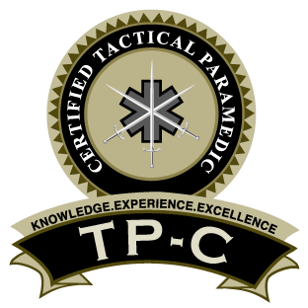
To: [Enter commander’s name here]

From: [Enter your name and title here]
Date: [Enter today’s date]
Subject: Request to sit for Certified Tactical Paramedic Examination

I would like to obtain my Certified Tactical Paramedic (TP-C) credential from the International Board of Specialty Certification (IBSC). The TP-C exam was developed to validate my knowledge to provide the best patient care in the tactical environment. The IBSC examination is the only specialty certification for tactical paramedics.
The Certified Tactical Paramedic (TP-C) Examination consists is focused on the knowledge level of accomplished, tactical paramedics in hostile and austere environments. The certification process is focused on decreasing preventable deaths at the point of wounding and is aligned with the three definitive phases of TECC/TCCC care. The questions on the examination are based in sound paramedicine and tactical principles found in TECC, TCCC and endorsed by C-TEC. Additionally, I am expected to maintain a significant knowledge of current ACLS and ITLS/PHTLS standards.
The TP-C exam is priced at $385 for computer-based exams and $335 for pencil/paper exams. By submitting this letter with your signature, I will receive a $100 discount off the examination fee.
This process will not only allow me to achieve this esteemed status but will provide an opportunity for me to demonstrate our department’s commitment to providing the best practices in the tactical environment. I am certain that this will provide a return on investment for our agency and for me professionally.

Commander’s Name and Title:
Department:
Commander’s Email:
Commander’s Signature:

After completing this form, please scan and return to jmyers@bcctpc.org
A refund in the amount of $100 will be returned to your original form of payment.

